TITLE OF THE PAPER (14 pt, capital letters, bold, centred)
2x free line, 12pt

Name SURNAME, Name SURNAME (12 pt, centred)
2x free line, 12pt

Abstract (12 pt, bold)
1x free line, 12pt
Text in English language, 10 lines maximum. (Times New Roman, 11pt, tabulator stop of the first line of the paragraph 1,25 cm; line spacing 1, fitting in block)
1x free line, 12pt
Keywords: 3 - 5 keywords in English separated by commas (11 pt)
1x free line, 12pt
Citation: SURNAME, N. 2026. Title of the paper. In National and International Security 2026. Proceeding of 17th International Scientific Conference. Liptovský Mikuláš: Armed Forces Academy of General M. R. Štefánik, p. ?? - ??. ISBN 978-80-8040-XXX-XX. DOI: https/doi.org/10.52651/…

2x free line, 12pt

INTRODUCTION (12 pt, capital letters, bold)
1x free line, 12pt
Text written in English language in whole paper. (Times New Roman, 12pt, tabulator stop of the first line of the paragraph 1,25 cm, line spacing 1, fitting in block, all the margins of the page 2,5 cm, paragraph spacing 6 pt).
References to the bibliography write directly in the text. Write text „of citation“ and behind it (Katuščák, 1998, p. 87), resp. text paraphrase and behind it (Katuščák, 1998). You can use comments in underline notes.
1x free line, 12pt
1 CHAPTER (12 pt, capital letters, bold)
1x free line, 12pt
Text ......... .......... ........... ......... ........ ........ .......... ........... ............ ......... ........ ...... ........ .......... ........... ......... ........ ........ .......... ......... .......... ........... ............ ......... ............ ......... .......... ........... ......... ........ ........ .......... ......... .......... ........... ............ ......... ............ ......... .......... ........... ......... ........ ........ .......... ......... .......... ........... ............ ......... ............ ......... .......... ........... ......... ........ ........ .......... ......... .......... ........... ............ ......... ............ ..................... ......... ........... ............ ......... ............ ........... ............ ......... ............
1x free line, 12pt
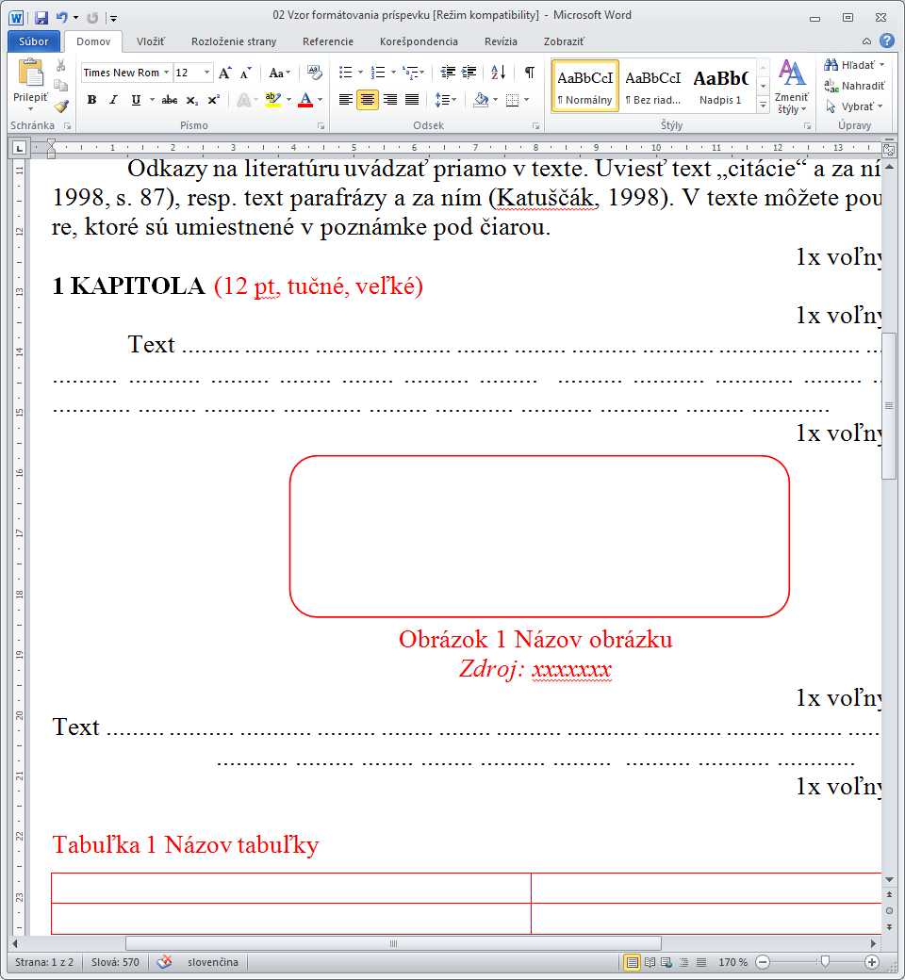
Picture 1 Name of picture
Source: xxxxxxx
1x free line, 12pt
Text ......... .......... ........... ......... ........ ........ .......... ........... ............ ......... ........ ...... ........ .......... ........... ......... ........ ........ .......... ......... .......... ........... ............
1x free line, 12pt

Table 1 Name of table
Source: xxxxxxx
1x free line, 12pt
1.1 SUBCHAPTER (12 pt, capital letters, bold)
1x free line, 12pt
Text ......... .......... ........... ......... ........ ........ .......... ........... ............ ......... ........ ...... ........ .......... ........... ......... ........ ........ .......... ......... .......... ........... ............ ......... ............ ......... ............ ......... ........... ............ ......... ............ ........... ............ ......... ............
1x free line, 12pt

CONCLUSION (12 pt capital letters, bold)
1x free line, 12pt
Text ......... .......... ........... ......... ........ ........ .......... ........... ............ ......... ........ ...... ........ .......... ........... ......... ........ ........ .......... ......... .......... ........... ............ ......... ............ ......... ............ ......... ........... ............ ......... ............ ........... ............ ......... ............
1x free line, 12pt
BibliograPHy
1x free line, 12pt
SURNAME, N. Year. Nomenclature. City: Editor. ??? p. ISBN.
SURNAME, N. N. Year. Nomenclature. In Name of proceedings. City: Editor, p. ?? - ??. ISBN.
SURNAME, N. - SURNAME, N. Year. Nomenclature of the paper. In Journal, Volume, Year, Number, ISSN, p. ?? - ??.
SURNAME, N. Year. Nomenclature. [online]. Available on internet: http://www.page.??.?/html
Write documents in alphabetical order with gaps between documents – 6pt.
3x free line, 12pt

Name SURNAME of author (s) with titles
Contact address
E-mail

Write text of the paper up to 20 pages.

