DECLARATION AND AUTHORITY

This is to confirm that author (co-author) signed bellow has not published the contribution titled ....................................................................................................................... ....................................................................................................................................................... in another publication neither submitted it for the publishing up to date of submission
to the Science & Military journal.
The author (co-author) declares that he has accepted the reasonable comments
of reviewers and accordingly amended the submitted contributions.
The author (co-author) declares that he is aware of the fact the editorial staff will not do a grammatical correction of the contribution. He is fully responsible for the grammatical
and linguistic correctness.
At the same time, it authorizes the Editorial board of Science & Military journal
to publish this contribution in Science & Military journal ISSN 1336-8885
(print) and Science & Military journal ISSN 2453-7632 (online on the website at: http://sm.aos.sk/index.php/en/archive ).
The Science & Military journal is published in accordance with an open access under the Creative Commons Attribution – NoDerivatives International Licence (CC BY-ND 4.0) http://creativecommonslorg/licenses/by/4.0.
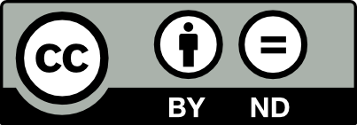

Author (co-author) of the contribution:

.................................................... ...........................................
.................................................... ...........................................
Given name, surname Signature

